Looking back in history to the people who inspire us!

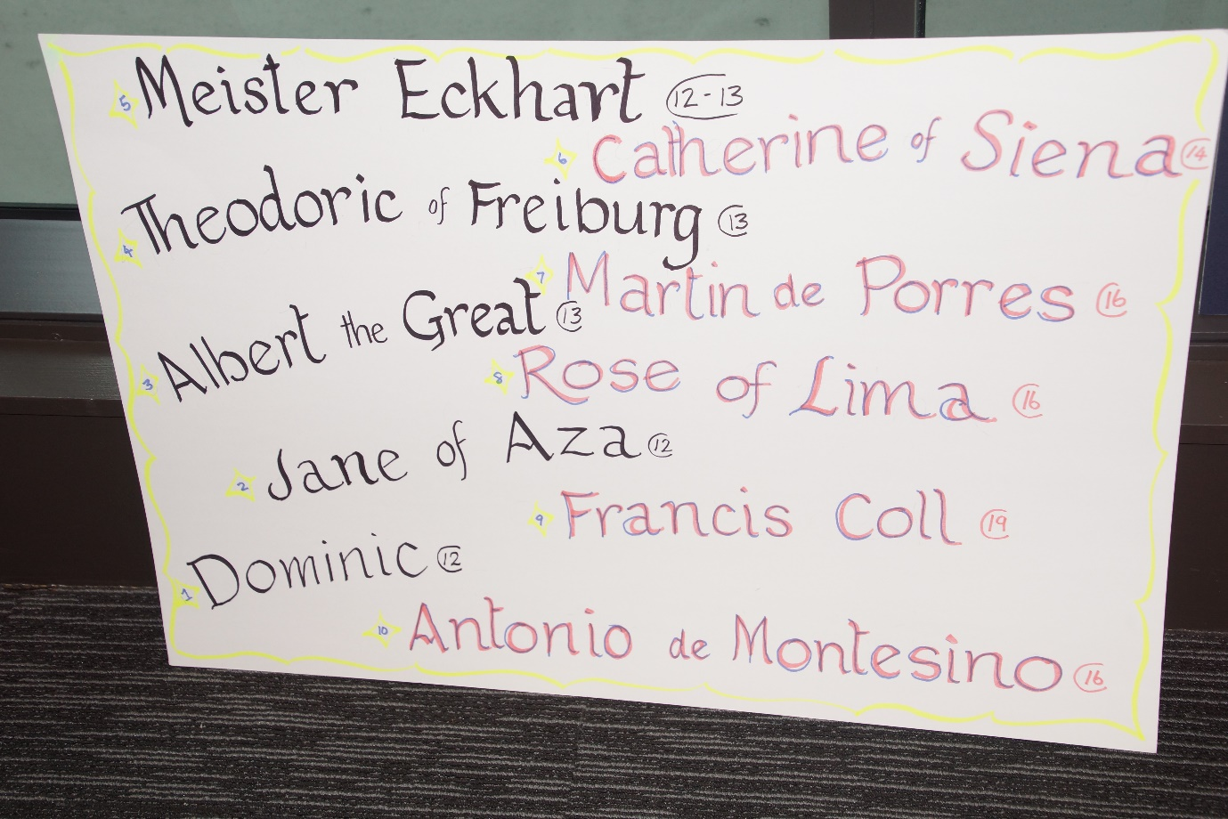

- Dominic
To understand Dominic’s mission we need to look at the world in which he lived.
The late 12th century saw the growth of a literate laity and people became aware of the stark contrast between the simplicity of Gospel-living and the opulent life-style of the clergy.
As a result of this, people turned away from the church and joined groups which offered alternative forms of Christian living.
Dominic spent nine years preaching among the Albigensians.
The seed was sown and the Order of Preachers was born, radically different from what already existed in the Church.
The Preachers lived in poor communities and were sent out to preach the Truth.
The road and the cloister were equally important.
So we can say that Dominic’s mission was to be a community contemplative, and itinerant preacher of the Truth

- Jane of Aza
Will be added in December.

- Albert the Great
13th c. German friar, Albert the Great developed a love of theology and science while at the University of Padua. Like Aquinas, both men were grounded in the thought of Aristotle. Both saw the world as God’s amazing gift. For Albert, mission meant studying mines, minerals, marble and soil. One example reveals his respect for nature’s intricacies. At one point, “Albert came upon a long-hidden well where a worker had descended, suffocated and died. When the locals called down vengeance on the water spirits Albert replied by explaining that gases can build up in a closed well. He suggested airing the well, and in a short time, the people would again have fresh drinking water. And, apparently, … so it happened.” Albert’s mission was to be a scientist within God’s creation.
- Theordoric of Freiburg
Theodoric of Freiburg (Meister Dietrich, Saxony) before 1250 - after 1310
MEISTER DIETRICH OF SAXONY, often called THEODORIC OF FREIBURG
Guten tag, alles. A great beauty of the environment is the rainbow. 42 is a number of the rainbow - well, 42 degree radius measures the size of the rainbow.
In 1959 a review appeared: saying that our Theodoric worked that out in Germany by 1300! Shock! We thought it was first done in the seventeenth century. Al-Fārasī did the same in Egypt, about the same time. They used spherical flasks of water to show how sunlight would be bent, reflected, and split into colours, by a raindrop or dewdrop.
Theodoric was a scholar, a writer, a superior, and when older mostly a preacher - the first to preach in German.
Whatever you quoted, he’d challenge you: Prove it! If only that had been said through the next 200 years, science would have been a development instead of a revolution.

- Meister Eckhart
This time 700 years ago Meister Eckhart was busy teaching theology, philosophy, Sacred Scripture in Cologne Germany. A great preacher and mystic.
People thronged to hear him wherever he went because he preached to the people in their own language, instead of Latin. (requirement of the day.)

He had the gift of passing on profound theology in a graphic style easily understood by everyone.

For Eckhart and his thousands of followers the Scriptures became a living reality, a basis for prayer and lifestyle.

Prayer groups and meditation groups sprang up where ever he went and so strengthened the Prayer movement called the Rhineland Mystics.
Lay groups such as the Friends of God, his brother Dominicans John Tauler and Henry Suso carried on his itinerant preaching mission.

Even today many people pursuing spirituality and contemplation are greatly influenced by This great mystic, eg (Eckhart Tolle). Philosophers,sociologists and psychologists etc. explore his writings and ponder his wisdom.

- Catherine of Siena (1347-1380)
A Light to the World
Catherine of Siena, our sister was a true mystic, while living a very active life. She was ultimately responsible for the return of Pope Gregory XI from Avignon to Rome. Her life was consumed with an extraordinary sense of mission on behalf of Christ for the world within her grasp.
In deed and in truth, she showed love for God’s church and for the papacy.
Within her short life she gave us a lesson in courage – the courage of telling the truth for love of the church, and for love of God’s people.
Imprinted with the sacred stigmata, she died in Rome at the age of 33. She was proclaimed Patroness of Italy in 1939 and in 1970, Pope Paul VI proclaimed her Doctor of the Church.

- Martin de Porres
St Martin was born in 1579 in Lima, Peru to a freed African slave woman, while his father was a Spanish nobleman/soldier. Martin grew up with no advantages but God’s grace. He became apprenticed as both a pharmacist/barber then entered the Dominican priory at 15, as a servant, and soon became advanced in a mission of great humility and charity to those he cared for in the monastery and in the streets. He had great devotion to the Eucharist and to St Dominic’s way of prayer during the night. His mission to the poorest made him the first black Saint from the Americas.
- Rose of Lima
Will be added in December.

- St Francis Coll 1812-1875 (feast April 2)

St Francis Coll was a nineteenth century Saint. For him mission meant preaching the good news of the Gospel, imitating the life-style of St Dominic as an itinerant preacher, and going to where the people gather, the market-place, the town-centre, and speaking about their Catholic faith, encouraging them to lead a Christian and moral life. He also gave missions to the outlying parishes, and made a good impression by his preaching and holiness. He founded a congregation of Dominican Sisters to teach poor children, and they have foundations in Spain, South America and Africa.

- Antonio de Montesino
In early 16th century ‘new world’ Hispaniola, the Dominican friars observed the atrocious treatment measured out to the indigenous people by the Spanish conquistadors as colonists. The Dominican community in Santo Domingo collectively wrote a sermon which unreservedly condemned such ill treatment. They chose a young friar, known for his eloquent preaching, to deliver the sermon. On the first Sunday of Advent 1511, Antonio de Montesinos rose to preach:
“By what right and by what law do you hold these Indians in such cruel and horrible servitude?
By whose authority have you made such detestable war on these people who live peacefully in their lands?
They die daily for the work you demand of them .... By what right ....?”

