People who inspire us today!

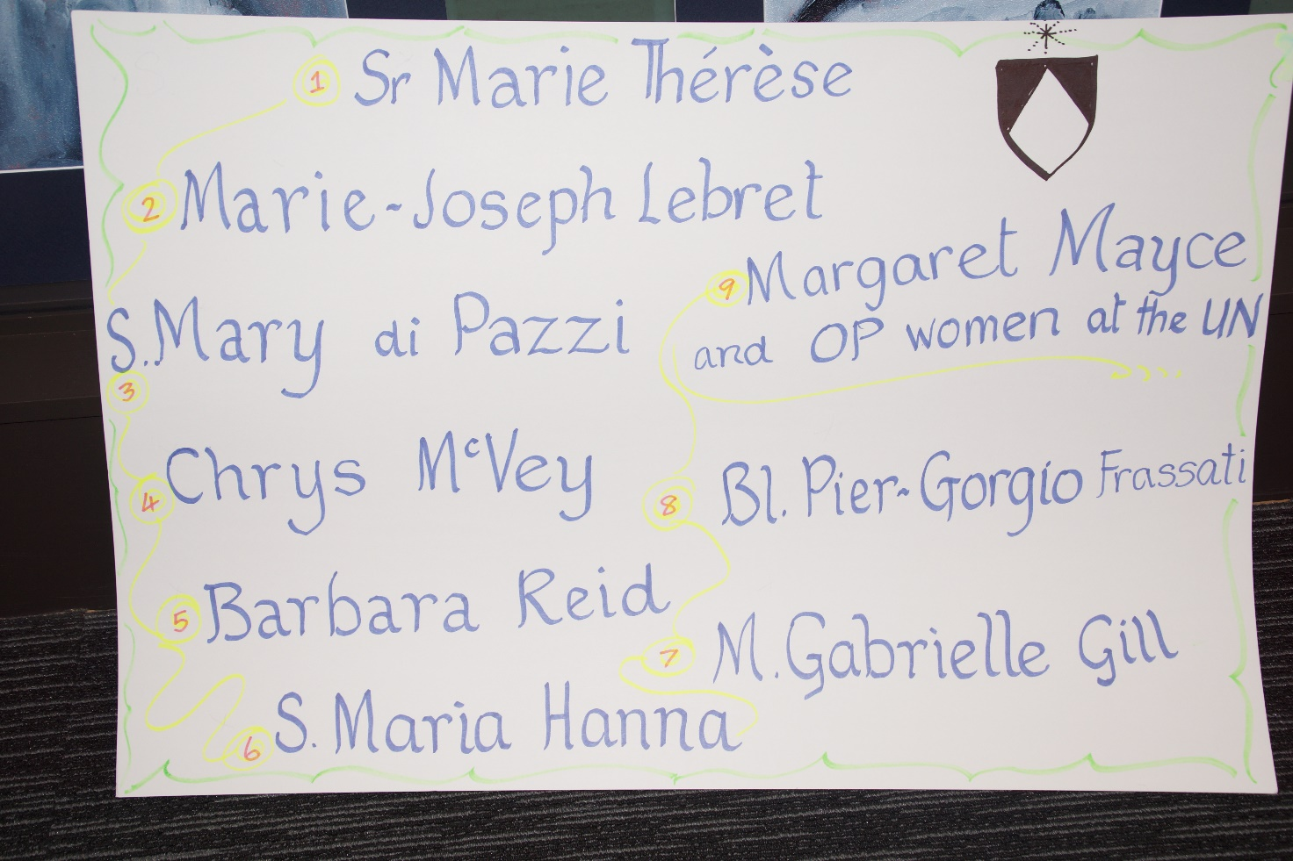

- Sr Marie Therese
Sr Marie Therese was born in Dunedin in 1911 and professed as a Dominican Sister in 1952.
In the context of Dominican Religious Life, teaching was her mission. She knew the importance of preparation for the mission and worked assiduously to educate herself, enabling her to be a wonderful teacher to the many people entrusted to her care.
I knew Sr Marie Therese in the late 1950’s when she had responsibility for the student sisters who did not have access to Teachers’ College.
She enhanced our learning opportunities by setting up the Scholasticate, enlisting all the resources available to her for tutorials and classes, and time-tabling students for teaching practice with experienced teachers.
This is just a tiny glimpse of a multi-faceted mission spanning over sixty years, a mission enriched with warmth, compassion, astuteness and persistence.
Sr Marie Therese was a truly contemplative, itinerant preacher of the Good News.

- Marie-Joseph Lebret
Will be added in December.

- Sister Mary di Pazzi Gaffaney, 1891-1960

Sister Mary di PAZZI Gaffaney. Tēnāra koutou katoa, nō Dunedin.

Mother di Pazzi was a Principal in our Dominican schools. Born Imelda in 1891, entered maybe at 21.

Think of her as the lady of the fires. Caught up twice in the loss of a convent. 1938, she and Sr St Roch had a dramatic escape at Northcote. 1958, as prioress of Invercargill, caring for the sisters burnt out of Bluff. Between those two fires: 5 pianos lost. Soon the people of Bluff gave them a piano and a car. Some of you remember that car.

A young scientist asked Mother di Pazzi for help with theology of creation. She provided parts of the Summa, WITH the much more accessible Companion by Farrell. I suspect she then decided he should become a priest, insisted on it before God. And so later it happened her way.

- Chrys McVey
American Dominican – over 40 years a missionary in Pakistan.
• humbled by the deep faith of Muslims during difficult times.
• He discovered a new way of seeing the great mystery of his own faith.
• And found such a deep encounter is a true adventure that expands our being and helps us understand others.
• Chrys died suddenly on a busy railway station in 2009.
But a year or two before that he came to Auckland – telling us to welcome strangers the Theology of Hospitality leads us to see another Face of God and leads us in the path of Truth and interfaith dialogue.

The Gospel of Jesus Christ has an amazing power to enable us to be at home in any culture, anywhere, at any time.

He called this discovery “Being outside the Camp.”

- Barbara Reid OP (1953 - )
Barbara Reid is a North American Dominican sister whose mission has been and still is as a Scripture scholar, writer and teacher.
During the 1980s, Barbara studied at the Catholic University of America for her PhD in Biblical Studies.
Fluent in Spanish, she has been able to engage with women in Peru and with Spanish-speaking people in the USA, relating the gospels to their ordinary lives.
As a Scripture scholar, Barbara has produced a scholarly edition of Matthew’s gospel and is currently General Editor of a 58 volume Feminist Commentary on the Bible. Her writing on the gospels for Sunday of Years A, B, and C has made her scholarship accessible to all.
Barbara has visited New Zealand on two occasions working with our Dominican Family and teaching portions of Biblical Studies at the National Seminary.
- Sister Maria Hanna OP
Sister Maria Hanna is Prioress of the Iraqi Dominican Sisters of St Catherine of Siena. The mission of this congregation is education, pastoral work and health care. Today their mission is no longer in hospitals and colleges but in the camps in Erbil. S Maria tells us children are the real victims in the displaced families living for over a decade with war and real persecution so she has mobilised her own exiled community to help them. Last April ISIS made their HQ in the motherhouse in Qaraqosh, but the Sisters still have hope. May we unite ourselves in prayer to this OP mission of mercy.
- Gabrielle Gill
Will be added in December.
- Bl Piergiorgio Frassati 1901-1925 (feast, July 4)

PIER GIORGIO FRASSATI was a 20th century Blessed. He belonged to the Dominican Family and for him Mission meant handing on the fruit of contemplation to the young people of Turin (in Italy), encouraging them to remain loyal to their traditional Catholic Faith, at a time when fascist movements were springing up looking for adherents. He went with the young people on tramps to the hills and used the opportunity that that gave him of speaking about their faith. He also befriended the poor of Turin and helped them as much as he could out of his meagre resources. When he died suddenly at the age of 24 the poor and the young flocked to his funeral.

- DOMINICAN WOMEN AT THE UNITED NATIONS
Dominican women have been represented at the United Nations for nearly 30 years. Initially, under the mantle of the Dominican Leadership Conference USA, and more recently Dominican Sisters International, Sisters Eileen Gannon and Margaret Mayce have advocated on our behalf around the question:
What can we do to serve both people and planet?
At the UN, New York, their mandate has been ‘to promote a human rights-based approach to development which upholds the rights of all people and respects the integrity of Earth and her eco-systems’.
In bringing her experience to our doorstop in Aotearoa, Margaret addressed the Sisters’ 2015 Chapter:
“Who are you to become ... as women called to hope at this critical moment in Earth’s history, and yours as well? .... Surely some revelation is at hand.”
- Louis Joseph Lebret (1897-1966)
As a young friar, while French Dominican Louis Joseph Lebret was recovering from illness in Northern France he encountered local fishermen whose family livelihoods were being threatened and terminated by the arrival of large fishing companies. With this experience and others, Lebret eventually established in Marseilles an educational centre to bring together experts in economics, human communities and industry. There, they reflected on issues regarding production and ownership, equality and inequality. For Lebret, Mission meant first, to seek out the causes of injustice and take action to right them and second, to work for economic justice which he saw as indispensable for global peace.

