Looking back in history to the people who inspire us!

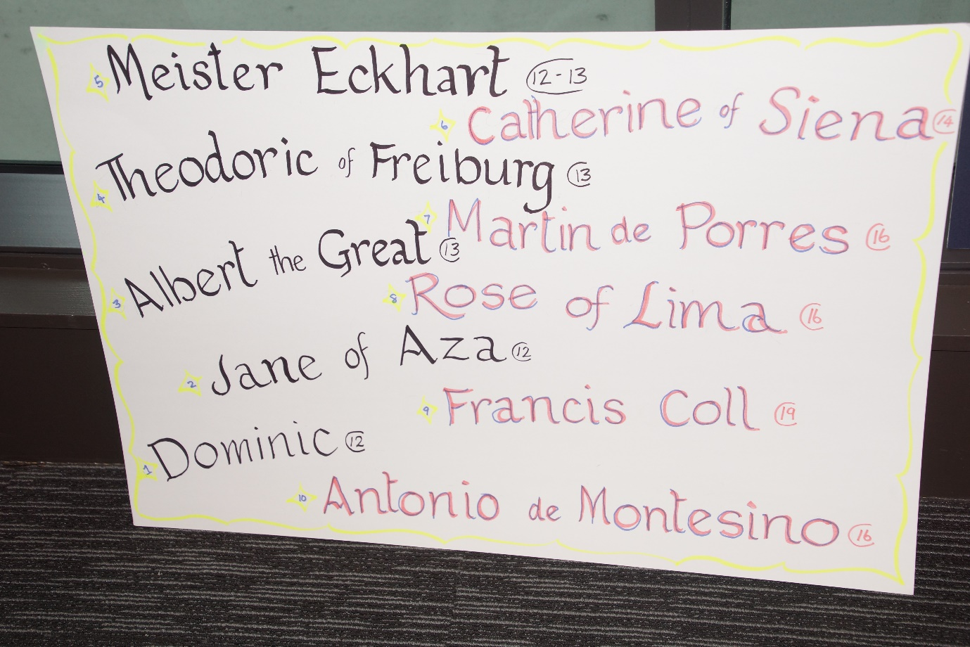

- Dominic de Guzman (1170-1221)

To understand Dominic’s mission, we need to look at the world in which he lived.
The late 12th century saw the growth of a literate laity and people became aware of the stark contrast between the simplicity of Gospel-living and the opulent life-style of the clergy.
As a result of this, people turned away from the church and joined groups which offered alternative forms of Christian living.
Dominic spent nine years preaching among the Albigensians.
The seed was sown and the Order of Preachers was born, radically different from what already existed in the Church.
The Preachers lived in poor communities and were sent out to preach the Truth.
The road and the cloister were equally important.
So we can say that Dominic’s mission was to be a community contemplative, and itinerant preacher of the Truth

- Albert the Great (c. 1200 - 1280)
13th c. German friar, Albert the Great developed a love of theology and science while at the University of Padua. Like Aquinas, both men were grounded in the thought of Aristotle. Both saw the world as God’s amazing gift. For Albert, mission meant studying mines, minerals, marble and soil. One example reveals his respect for nature’s intricacies. At one point, “Albert came upon a long-hidden well where a worker had descended, suffocated and died. When the locals called down vengeance on the water spirits Albert replied by explaining that gases can build up in a closed well. He suggested airing the well, and in a short time, the people would again have fresh drinking water. And, apparently, … so it happened.” Albert’s mission was to be a scientist within God’s creation.
- Theodoric of Freiburg (c.1250-c.1310)
Theodoric of Freiburg, or Meister Dietrich of Saxony, was born before 1250 and died around 1310.

He was enthralled by the beauty of the environment and especially of the rainbow. 42 is a number of the rainbow. But, a 42 radius measures the size of the rainbow. In 1959 a review appeared, saying that Theodoric had explained that in Germany by 1300!

General acceptance was that it had been first done in the 17th century, and Al-Fārasī had done the same in Egypt, about the same time. Both men used spherical flasks of water to show how sunlight would be bent, reflected, and split into colours, by a raindrop or dewdrop.

Theodoric was a scholar, writer, superior, and when older mostly a preacher - the first to preach in German. Whatever you quoted, he’d challenge you, saying ‘Prove it!’ If only that had been said through the next 200 years, science would have been a development instead of a revolution.

- Meister Eckhart (1260-c.1328)
This time 700 years ago Meister Eckhart was busy teaching theology, philosophy, Sacred Scripture in Cologne Germany. He was a great preacher and mystic.
People thronged to hear him wherever he went because he preached to the people in their own language, instead of in Latin - which was a requirement of the day!)

He had the gift of passing on profound theology in a graphic style easily understood by everyone.

For Eckhart and his thousands of followers the Scriptures became a living reality, a basis for prayer and lifestyle.

Prayer groups and meditation groups sprang up where ever he went and so strengthened the Prayer movement called the Rhineland Mystics.
Lay groups such as the Friends of God, his brother Dominicans John Tauler and Henry Suso carried on his itinerant preaching mission.

Even today many people pursuing spirituality and contemplation are greatly influenced by This great mystic, eg (Eckhart Tolle). Philosophers,sociologists and psychologists etc. explore his writings and ponder his wisdom.

- Catherine of Siena – A Light to the World (1347-1380)
Catherine of Siena, our sister was a true mystic who lived a very active life. She was ultimately responsible for the return of Pope Gregory XI from Avignon to Rome. Her life was consumed with an extraordinary sense of mission on behalf of Christ for the world within her grasp.
In deed and in truth, she showed love for God’s church and for the papacy.
Within her short life she gave us a lesson in courage – the courage of telling the truth for love of the church, and for love of God’s people.
Imprinted with the sacred stigmata, she died in Rome at the age of 33. She was proclaimed Patroness of Italy in 1939 and in 1970, Pope Paul VI proclaimed her Doctor of the Church.

- Martin de Porres (1579-1639)

St Martin was born in 1579 in Lima, Peru to a freed African slave woman, while his father was a Spanish nobleman/soldier. Martin grew up with no advantages but God’s grace. He became apprenticed as both a pharmacist/barber then entered the Dominican priory at 15, as a servant, and soon became advanced in a mission of great humility and charity to those he cared for in the monastery and in the streets. He had great devotion to the Eucharist and to St Dominic’s way of prayer during the night. His mission to the poorest made him the first black Saint from the Americas.
- Rose of Lima (1586-1617)

Rose was born in 1586 and as a young girl she chose to emulate St Catherine of Siena by spending her short life as a Catholic lay woman, living the spirituality of the Dominican Third Order, in her own home.
She spent the early hours of each day in contemplation and from there she lived the love of God which filled her life.
Marginalization and discrimination of different groups of the poor surrounded her.
Her days were spent, caring for the sick and hungry. She earned the money for this mission by selling the flowers she grew and the embroidery and lace she made at the local markets. For eleven years, she sought to find the face of the Lord in the faces of the poorest people of Lima in her time, eventually dying at the age of 31. Her life serves as an incentive for our own search.

- St Francis Coll (1812-1875)

St Francis Coll was a nineteenth century Saint. For him mission meant preaching the good news of the Gospel, imitating the life-style of St Dominic as an itinerant preacher, and going to where the people gather, the market-place, the town-centre, and speaking about their Catholic faith, encouraging them to lead a Christian and moral life. He also gave missions to the outlying parishes, and made a good impression by his preaching and holiness. He founded a congregation of Dominican Sisters to teach poor children, and they have foundations in Spain, South America and Africa. His feast day is celebrated on April 2nd.

- Antonio de Montesinos (c. 1475 -1545)
In early 16th century ‘new world’ Hispaniola, the Dominican friars observed the atrocious treatment measured out to the indigenous people by the Spanish conquistadors as colonists. The Dominican community in Santo Domingo collectively wrote a sermon which unreservedly condemned such ill treatment. They chose a young friar, known for his eloquent preaching, to deliver the sermon. On the first Sunday of Advent 1511, Montesinos arose to preach:
“By what right and by what law do you hold these Indians in such cruel and horrible servitude? By whose authority have you made such detestable war on these people who live peacefully in their lands? They die daily for the work you demand of them .... By what right ...?”

