Recent Dominican Women and Men who have Inspired us!

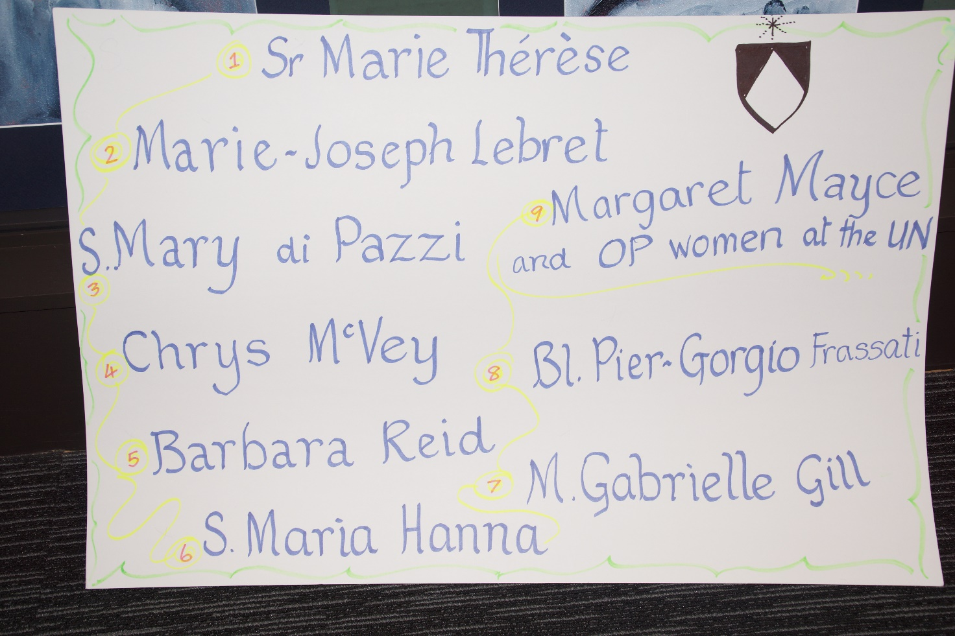

- Marie Therese Smith OP
Sr Marie Therese was born in Dunedin in 1911 and professed as a Dominican Sister in 1952.
In the context of Dominican Religious Life, teaching was her mission. She knew the importance of preparation for mission and worked assiduously to educate herself, enabling her to be a wonderful teacher to the many people entrusted to her care.
I knew Sr Marie Therese in the late 1950’s when she had responsibility for the student sisters who did not have access to Teachers’ College.
She enhanced our learning opportunities by setting up the scholasticate, enlisting all the resources available to her for tutorials and classes, and time-tabling students for teaching practice with experienced teachers.
This is just a tiny glimpse of a multi-faceted mission spanning over 60 years, a mission enriched with warmth, compassion, astuteness and persistence.
Sr Marie Therese was a truly contemplative, itinerant preacher of the Good News.
- Louis Joseph Lebret OP (1897-1966)
As a young friar, while French Dominican Louis Joseph Lebret was recovering from illness in Northern France he encountered local fishermen whose family livelihoods were being threatened and terminated by the arrival of large fishing companies.
With the above experience and others, Lebret eventually established in Marseilles an educational centre to bring together experts in economics, human communities and industry. There, they reflected on issues regarding production and ownership, equality and inequality.
For Lebret, Mission meant first, to seek out the causes of injustice and take action to right them and second, to work for economic justice which he saw as indispensable for global peace.

- Mary di Pazzi Gaffaney OP (1891-1960)
Sister Mary di Pazzi Gaffaney! Tēnāra koutou katoa, nō Dunedin.

Mother di Pazzi was a Principal in our Dominican schools. Named as Imelda in 1891, she entered around the age of 21.

We might think of her as the lady of the fires. She was caught up twice in the loss of a convent. In 1938, she and Sr Mary St Roch had a dramatic escape at Northcote. In 1958, as prioress of Invercargill, she cared for the sisters whose home was burnt in Bluff. Between those two fires, five pianos were lost. However, very soon afterwards, the people of Bluff gave them a piano and a car. Some of you will remember that car!

A young scientist asked Mother di Pazzi for help with a theology of creation. She provided parts of the Summa, with the much more accessible Companion to the Summa by Walter Farrell OP. I suspect that Mother then decided that the scientist should become a priest, insisting on it before God. And later, it happened her way.

- Chrys McVey OP (1933-2009)

Chrys was an American Dominican friar who spent over 40 years as a missionary in Pakistan. He was humbled by the deep faith of Muslims during difficult times and discovered a new way of seeing the great mystery of his own faith. He found such a deep encounter as a true adventure which expanded his being, helping him to understand others. He died suddenly at a busy railway station in 2009.
A year or two prior to that he had come to Auckland – telling us to welcome strangers since a theology of ‘hospitality’ can lead us to see another face of God and to discover the path of Truth within interfaith dialogue.

He held that the Gospel has an amazing power which enables us to be at home in any culture, anywhere, at any time. He called such a discovery “Being outside the Camp.”

- Barbara Reid OP (1953 - )
Barbara Reid is a North American Dominican sister from Grand Rapids whose mission has been and still is as a Scripture scholar, writer and teacher.
During the 1980s, Barbara studied at the Catholic University of America for her PhD in Biblical Studies.
Fluent in Spanish, she has been able to engage with women in Peru and with Spanish-speaking people in the USA, relating the gospels to their ordinary lives.
As a New Testament scholar, Barbara has produced a scholarly edition of Matthew’s gospel and is currently General Editor of a 58 volume Feminist Commentary on the Bible. Her writing on the gospels for Sunday of Years A, B, and C has made her scholarship accessible to all.
Barbara has visited New Zealand on two occasions working with our Dominican Family and teaching portions of Biblical Studies at the National Seminary.
- Maria Hanna OP
Sister Maria Hanna is Prioress of the Iraqi Dominican Sisters of St Catherine of Siena. The mission of this congregation is education, pastoral work and health care.
Today, the Sisters’ mission is no longer in hospitals and colleges but in the camps of Erbil. Sr Maria tells us that children are the real victims in the displaced families living for over a decade with war and real persecution. Therefore, she mobilised her own exiled community to help them. Last April, ISIS made their Headquarters in the Sisters’ motherhouse at Qaraqosh, but the Sisters still have hope.
May we unite ourselves in prayer to this OP mission of mercy!
- Mother Gabrielle Gill OP

The foundress of the New Zealand Dominican Sisters, Mother Gabriel Gill, began her Dominican life as a teacher in the large cloistered convent in Sion Hill Dublin.
One day in 1870 the newly appointed Bishop of Otago and Southland – Bishop Moran – visited and asked for volunteers to set up Catholic schools to educate the children of the thousands of Catholics who had joined the Otago gold rush in 1861.
Mother Gabriel and nine other Sisters generously answered his plea, arriving by sailing boat at Port Chalmers on Friday, 18th February, 1871. On the following Monday, they opened their first school in Dunedin.

By 1893, six new foundations had been established in the Dunedin Diocese.

Hence the Title of her Biography – “Mother of the Missions.”
- Blessed Piergiorgio Frassati OP

Pier Giorgio Frassati (1901-25) was a 20th century ‘Blessed’. He belonged to the Dominican Family and for him ‘Mission’ meant to hand on the fruit of contemplation to the young people of Turin, Italy, encouraging them to remain loyal to their traditional Catholic Faith, at a time when Fascist movements were springing up and seeking adherents.

He would go with young people on tramps to the hills and use the opportunity which that gave him of speaking about their faith. He also befriended the poor of Turin and helped them as much as he could from his meagre resources.

When he died suddenly at the age of 24, the poor and the young flocked to his funeral.

- Dominican Women at the United Nations
Dominican women have been represented at the United Nations for nearly 30 years. Initially, under the mantle of the Dominican Leadership Conference USA, and more recently under the umbrella of Dominican Sisters International, Sisters Eileen Gannon and Margaret Mayce have advocated on our behalf around the question, ‘What can we do to serve both people and planet?’

At the U.N. in New York, their mandate has been “to promote a human rights-based approach to development which upholds the rights of all people and respects the integrity of Earth and her eco-systems.”
In bringing her experience to our doorstep in Aotearoa NZ, Margaret addressed the Sisters’ 2015 Chapter: “Who are you to become .... as women called to hope at this critical moment in Earth’s history, and yours as well? .... Surely some revelation is at hand.”

